# Lab: Generics, Iterators and Comparators

This document defines the lab overview for the ["C# OOP Advanced" course @ Software University](https://softuni.bg/trainings/1637/c-sharp-oop-advanced-july-2017). Please submit your solutions (source code) of all below described problems at the end of the course at [softuni.bg](https://softuni.bg/).

# Introduction

In the last few labs all we've been doing is refactoring the **BashSoft** application with all kinds of good practices of **OOP** and **OOD** (object oriented design). We must admit that although necessary, that has been kind of boring. Now that we've learned about **Generics**, **Iterators** and **Comparators** it's a good moment to finally add some new functionality to our project. We will create our own data structure called **SimpleSortedList.** It will have some normal methods for a list but it will differ slightly because the elements inside it will always be sorted. Kind of like a **SortedSet** with repeating elements. Such an abstract data structure is called an **OrderedBag**.

**Note that our implementation will be very slow in terms of performance because that is not the focus of the current material. If you are interested in making it fast you may learn about that and much more in the** [**Data Structures**](https://softuni.bg/courses/data-structures) **course at SoftUni.**

# Implementing the SimpleSortedList Data Structure

Let's start with the interface so we know what features our data structure should have in case we (or someone else) decide to do a different implementation of it. Call the interface **ISimpleOrderedBag.** It will be simple because we don't plan to add much functionality to it for now and it will not have the best implementation as we mentioned. If we decide we need more the interface can be extended. Our interface should have the methods: A**dd**, **AddAll**, **Size** and **JoinWith** (a method which will assist in printing). It should also keep a **generic type** that is **comparable** and the bag itself should be **iterable.** This is how it should look (don't forget about good formatting of empty lines and spaces):

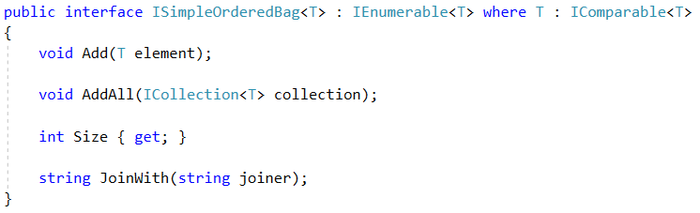

Now that we've created the interface it's time for the class itself. Let's start with creating a new folder called **DataStructures.** In it make a new class called **SimpleSortedList**.We will need three fields inside - one for keeping the **internal collection** (a generic array), one for holding the size of our list, and one for the comparator of our sorted list. Don't forget to also write the correct class signature. We will also need a constant field to keep a default field for our list.

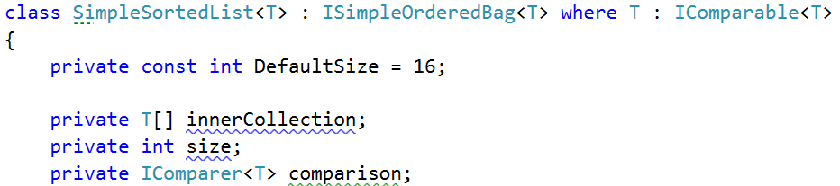

Notice how we have unimplemented methods?

Well we will implement them later because we should do the constructors first. The first one will accept **the most** **parameters** - a comparer and capacity. Don't forget to **validate** the capacity!

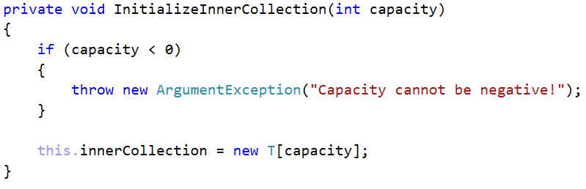

The **second** constructor will have a default comparer:

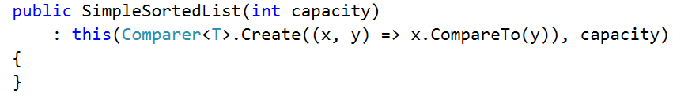

The **third** will have a **default capacity** and the **fourth** one will have both **capacity and comparer to be default**. Implement them by yourself.

OK, now let's start implementing the interface. The **Size** property should just return our size field as is:

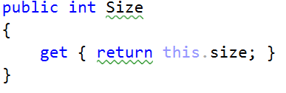

The **Add** method should set the element at the current **size index of our inner collection** to the generic element passed to it. Then **increment the size** and finally **sort the inner collection**, because after all we're creating a **sorted list.**

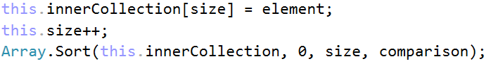

Well as Nakov says this should work like a dude, except… not always. What happens when our inner array is full? The answer is - **IndexOutOfRangeException.** To prevent this, we need to resize our array. We basically need to copy our array into a new one that is twice as big and leave the empty values to be null. The **Array.Copy** method can do this for us but let's wrap it in our own private method.

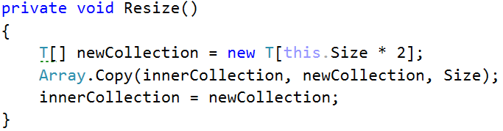

Now all that is left is to call this method when our **size** is bigger or equal to the inner array's length. This is how the **Add** **method** should look in the end:

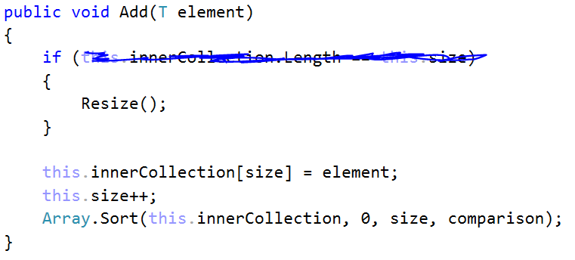

The **AddAll** method will work in a similar fashion as the **add** method. We could even implement it by calling **add** but that would trigger sorting at each element to be added, so a better approach would be to add all the elements and only sort once at the end.

However, resizing in this case might not be so simple because our current elements + the ones we want to add might be more than the inner collection's length * 2. Thus, we will have a slightly different resize approach (think about the logic behind this):

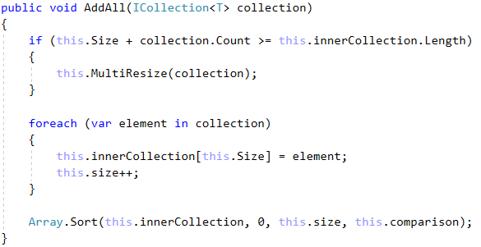

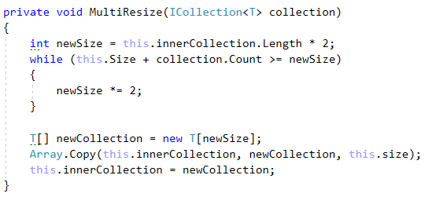

Now that we're done with the main functionality it's a good time to override the IEnumerator<T> GetEnumerator()method. Inside we should create a loop through the inner collection and yield return the current element.

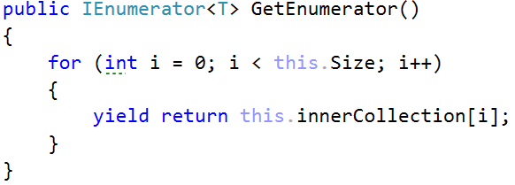

The last thing we need to implement is the **JoinWith** method. It will connect all the elements in our structure with the given **joiner** string. Since now we have the iterator, we can reuse it.

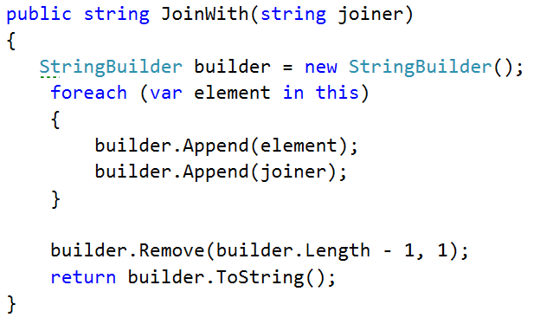

# Making Students and Courses Comparable

As always start by altering the interfaces:



Do the same for the Student interface. Then go to the classes. This would be a good time to **override** the **ToString** method of our SoftUniStudent/Course classes too:

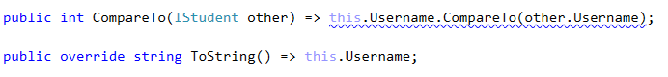

Do the same for the **SoftUniCourse** class, comparing them by **Name**.

# Adding functionality to the StudentsRepository

The methods we are going to add are most akin to the **Requester** interface which the **Database** interface extends. Thus, we will add our two new method signatures here:

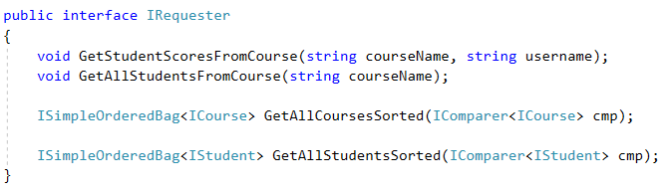

Now implement them in the **StudentRepository:**

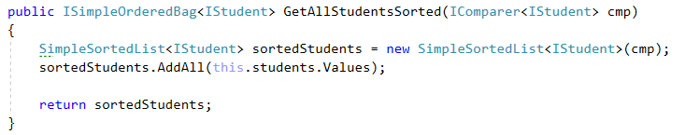

Notice how we can add the **values** from our **Dictionary** with the **AddAll** method of our **SimpleSortedList** because they are a **Collection**. The other one is exactly the same but with **Students,** implement it **by yourself**.

# Adding the new DisplayCommand

Start off by adding a case to our **CommandInterpreter's** **parseCommand** method:



Then create the matching class with the **usual constructor**. You can try to figure out an implementation for its execute command on your own. The command should receive two parameters in its input data - **entity to display** (students / courses) and **the** **order** in which to display the data (ascending/descending).

Try to reuse as much code as you can and use our SimpleSortedList's **JoinWith** command for printing.

Alternatively, you can look at our implementation. We won't go into much detail about it because it is not a subject of this lab:

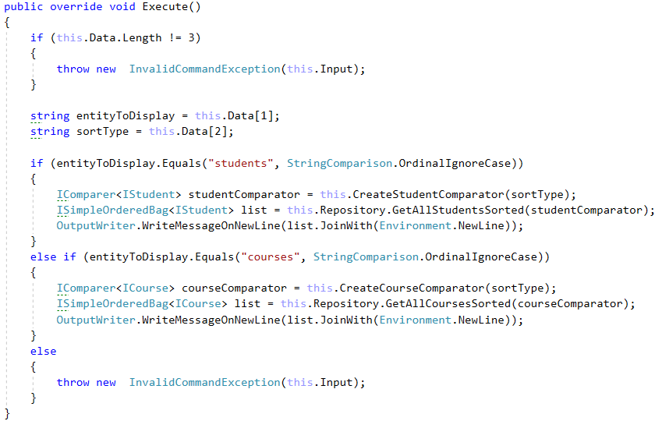

This is the **CreateStudentComparator** command, implement the other by **yourself:**

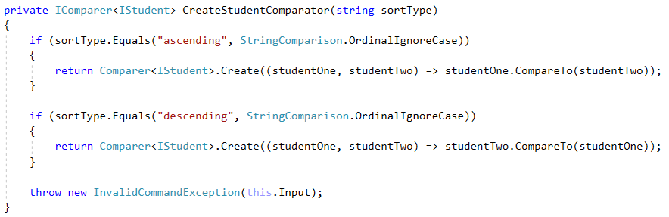

Finally go to the **GetHelpCommand** and add some more help info about our new command:



# Testing our new functionality

If you've implemented all the new functionality correctly you should get such a result:

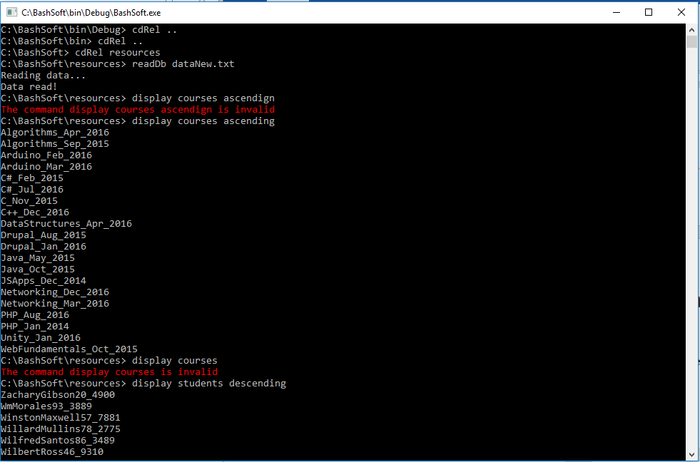

# * BONUS TASK: Implement your own sorting algorithm for the SimpleSortedList

Instead of using the state **Arrays.sort** method you can make your own **generic** sorting method inside our class. Use one of the following algorithms:

* **BubbleSort (easy difficulty)**
* **SelectionSort (easy difficulty)**
* **InsertionSort (medium difficulty)**
* **QuickSort (hard difficulty)**

You can research about them all around the internet, but here are some more interesting sources:

<http://visualgo.net/sorting> - great site with visualization of all the algorithms and more + pseudo code. A good programmer should never be **limited** to using just one language and should always be able to read pseudo code.

<https://softuni.bg/trainings/1331/algorithms-april-2016> - check out the lecture by **Atanas Rusenov** about Sorting and Searching Algorithms - 12 April 2016.